Argos Homework Programming Task
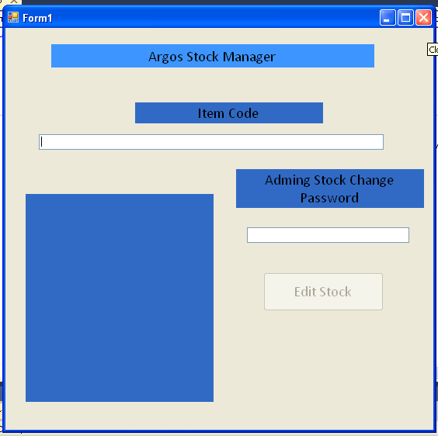

Dim Total As Single
Dim Price(10) As Single
Dim ItemCode(10) As Integer
Dim Stock(10) As Integer
Dim CStock As Integer
Dim Description As String

Private Sub ICtextbox_TextChanged(ByVal sender As System.Object, ByVal e As System.EventArgs) Handles ICtextbox.TextChanged

If Val(ICtextbox.Text) = ItemCode(1) Then
Description = "Apple iPod Touch 32GB 2nd Generation"
CStock = Stock(1)
Total = Price(1)
lblOutput.Text = "Description: " & Description & vbNewLine &
"Catalogue Number: " & ItemCode(1) & vbNewLine &
"Number in Stock: " & CStock & vbNewLine &
"Price: " & Format(Total, "Currency")

ElseIf Val(ICtextbox.Text) = ItemCode(2) Then
Description = "Bosch SMS63E02 Full Size Dishwasher"
CStock = Stock(2)
Total = Price(2)
lblOutput.Text = "Description: " & Description & vbNewLine &
"Catalogue Number: " & ItemCode(2) & vbNewLine &
"Number in Stock: " & CStock & vbNewLine &
"Price: " & Format(Total, "Currency")

ElseIf Val(ICtextbox.Text) = ItemCode(3) Then
Description = "PS3 GTA IV Bundle"
CStock = Stock(3)
Total = Price(3)
lblOutput.Text = "Description: " & Description & vbNewLine &
"Catalogue Number: " & ItemCode(3) & vbNewLine &
"Number in Stock: " & CStock & vbNewLine &
"Price: " & Format(Total, "Currency")

ElseIf Val(ICtextbox.Text) = ItemCode(4) Then
Description = "Panasonic NNGD566W Microwave and Grill"
CStock = Stock(4)
Total = Price(4)
lblOutput.Text = "Description: " & Description & vbNewLine &
"Catalogue Number: " & ItemCode(4) & vbNewLine &
"Number in Stock: " & CStock & vbNewLine &
"Price: " & Format(Total, "Currency")

ElseIf Val(ICtextbox.Text) = ItemCode(5) Then
Description = "Apple iPod touch 16GB"
CStock = Stock(5)
Total = Price(5)
lblOutput.Text = "Description: " & Description & vbNewLine &
"Catalogue Number: " & ItemCode(5) & vbNewLine &
"Number in Stock: " & CStock & vbNewLine &
"Price: " & Format(Total, "Currency")

ElseIf Val(ICtextbox.Text) = ItemCode(6) Then
Description = "HP Pavillion dv7-1004ea P8400 4GB 17inch Laptop"
CStock = Stock(6)
Total = Price(6)
lblOutput.Text = "Description: " & Description & vbNewLine &
"Catalogue Number: " & ItemCode(6) & vbNewLine &
"Number in Stock: " & CStock & vbNewLine &
"Price: " & Format(Total, "Currency")

ElseIf Val(ICtextbox.Text) = ItemCode(7) Then
Description = "Canon EOS 40D Digital SLR with 17-85mm Lens"
CStock = Stock(7)
Total = Price(7)
lblOutput.Text = "Description: " & Description & vbNewLine &
"Catalogue Number: " & ItemCode(7) & vbNewLine &
"Number in Stock: " & CStock & vbNewLine &
"Price: " & Format(Total, "Currency")

ElseIf Val(ICtextbox.Text) = ItemCode(8) Then
Description = "Sandisk 4GB Compact Flash"
CStock = Stock(8)
Total = Price(8)
lblOutput.Text = "Description: " & Description & vbNewLine &
"Catalogue Number: " & ItemCode(8) & vbNewLine &
"Number in Stock: " & CStock & vbNewLine &
"Price: " & Format(Total, "Currency")

ElseIf Val(ICtextbox.Text) = ItemCode(9) Then
Description = "Accurist ladies silver panther link DIAMOND set case mop dial bracelet"
CStock = Stock(9)
Total = Price(9)
lblOutput.Text = "Description: " & Description & vbNewLine &
"Catalogue Number: " & ItemCode(9) & vbNewLine &
"Number in Stock: " & CStock & vbNewLine &
"Price: " & Format(Total, "Currency")

ElseIf Val(ICtextbox.Text) = ItemCode(10) Then
Description = "Longridge 32 Pcs Golf Set"
CStock = Stock(10)
Total = Price(10)
lblOutput.Text = "Description: " & Description & vbNewLine &
"Catalogue Number: " & ItemCode(10) & vbNewLine &
"Number in Stock: " & CStock & vbNewLine &
"Price: " & Format(Total, "Currency")

End If

End Sub

Private Sub Passtextbox_TextChanged(ByVal sender As System.Object, ByVal e As System.EventArgs) Handles PassTextBox.TextChanged
Dim Password As Integer

Password = 999
If Val(PassTextBox.Text) = Password Then
btnCalculate.Enabled = True
End If

End Sub

Private Sub btnCalculate_Click(ByVal sender As System.Object, ByVal e As System.EventArgs) Handles btnCalculate.Click
Dim Prompt As String
Dim ArrayNo As Integer

Prompt = "Enter Array Number" & vbNewLine & "1 = " & ItemCode(1) & vbNewLine & "2 = " & ItemCode(2) & vbNewLine & "3 = " & ItemCode(3) & vbNewLine & _
"4 = " & ItemCode(4) & vbNewLine & "5 = " & ItemCode(5) & vbNewLine & "6 = " & ItemCode(6) & vbNewLine & "7 = " & ItemCode(7) & vbNewLine & _
"8 = " & ItemCode(8) & vbNewLine & "9 = " & ItemCode(9) & vbNewLine & "10 = " & ItemCode(10) & vbNewLine

ArrayNo = InputBox(Prompt, "Argos Stock Checker", 0)

Stock(ArrayNo) = InputBox("Enter Total Stock Available", "Argos CStock Checker", 0)

End Sub

Private Sub Form1_Load(ByVal sender As System.Object, ByVal e As System.EventArgs) Handles MyBase.Load

ItemCode(1) = 2044154
Stock(1) = 79
Price(1) = 288.76
ItemCode(2) = 2046774
Stock(2) = 28
Price(2) = 379.97
ItemCode(3) = 9012475
Stock(3) = 135
Price(3) = 329.71
ItemCode(4) = 2041683
Stock(4) = 14
Price(4) = 139.97
ItemCode(5) = 2048112
Stock(5) = 15
Price(5) = 218.97
ItemCode(6) = 2048558
Stock(6) = 94
Price(6) = 849.0
ItemCode(7) = 2021015
Stock(7) = 56
Price(7) = 879.96
ItemCode(8) = 2036059
Stock(8) = 9
Price(8) = 39.97
ItemCode(9) = 2043417
Stock(9) = 54
Price(9) = 80.0
ItemCode(10) = 2008775
Stock(10) = 32
Price(10) = 129.99

End Sub
End Class

